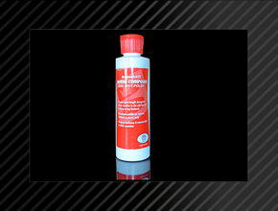

Bowlingtipps für Bowler‘s

http://www.bowling-sport-kiel.de/

English language
- Creates good length through the heads, traction in the mid-lane with a strong arcing backend.
- All purpose polish for reactive, urethane & plastic ball.
- Restores tackiness & removes light or minor scratches

Directions
Shake well before using. For best result use a professional ball spinner. Apply a generous amount of polish to a cotton towel and apply using a smooth even pressure over the ball, increasing the pressure while you polish. Then with a clean cotton towel and firm pressure, buff the rest of the polish into the ball. If the ball, divide it into 4 sides. First polish the top half of the ball and then turn it completely over to polish the bottom half. Then turn it halfway to polish one of the sides and finally turn it completely over to polish the other side.
Restoring the Royal Compound Factory Finish
First, evenly wet sand the ball to a 500 grit Pad finish, then follow the next steps. Follow the listed for the individual ball. For added length work up for 500 grit Pad to 800, 1000, 2000 and 4000 grit Pad and then follow the polishing directions. Note, each increment of Grit will old 1-2 feet (1 feet = 30,48 cm) in length. Individual results will vary based on the force that you/or your Spinner apply to the ball.

USBC, Approved Before/After
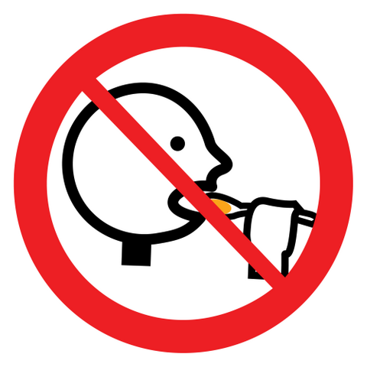Keep out of the reach of children!

© 2017 by Rüdiger Probst for http://www.bowling-sport-kiel.de/

